Core color values

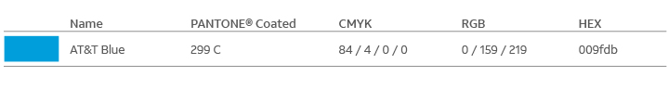

Primary color values

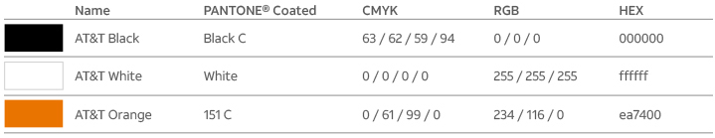

Secondary color values

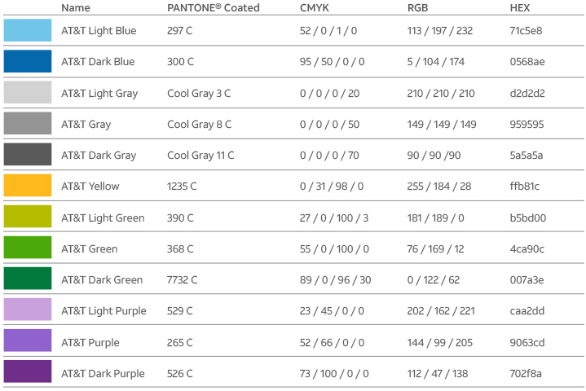

Functional color values

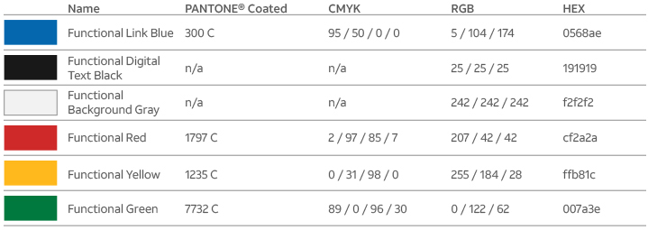

Pantone® is a registered trademark of Pantone, Inc.

*Note: Print applications saved as a digital application such as PDFs must use the RGB values noted above. PDF software’s auto conversion features will not produce an accurate color match to the above. Please rebuild design using RGB color match library.*

What you need to know for digital applications

We want to make sure our digital communications are easy to read for people with vision deficiencies, so be sure to use proper contrast for all text, call to action elements, and meaningful graphics (e.g., arrows and icons) used in digital applications such as websites, digital advertising, email, PowerPoint files, PDFs, videos, etc. (For more information on compliance on icons, take a look at our [icon](https://brandcenter.att.com/home/homepage.html#%21learn/reference/ourstorytellingelements:Illustration/guidelinepage:Iconography%7COur%20illustration%20style) guideline).

[Digital design center](http://digitaldesign.web.att.com/)

Take a look below for guidance on how to use our color palette with typography in digital applications.

Text on neutral backgrounds

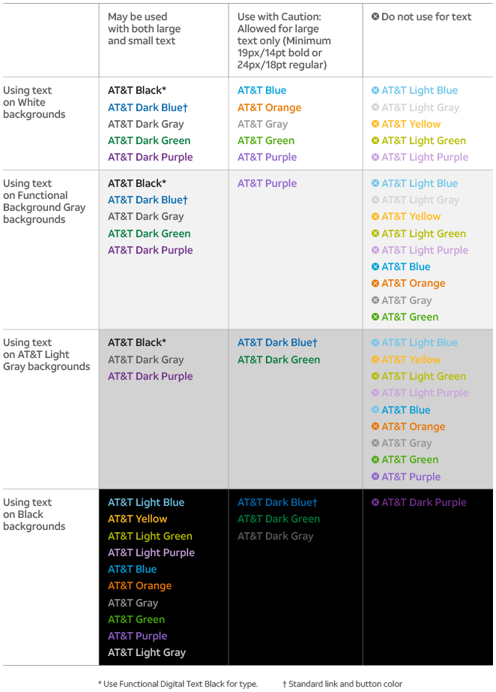

Text on color backgrounds

We only use black or white type on color backgrounds, as indicated.

